 |  | Monday, May 3  How to Parent to Prevent Substance Abuse, Communicate to Build a Trusting Relationship and Raise Children with Grit and Resilience  7pm - Zoom - Register Here  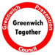 | Tree of Hope Tree Lighting  7:30 pm  Sherman Town Green  Fairfield, CT | Tuesday, May 4  Question. Persuade. Refer  QPR (suicide prevention) Training  5-6:30 pm Virtual  RSVP by emailing  info@thehubct.org | Stress Reduction Techniques for Life Harmony with Chris Salem  6PM Virtual  Register Here | Wednesday, May 5  Narcan Training  3-4:00pm Virtual  Register by emailing Kaitlin kaitlin@ryasap.org  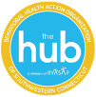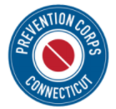 | SMART Recovery Teen Group  Free in-person groups for Norwalk Teens  3:30-5:00pm  BMHS/CGS Room 1205 | Thursday, May 6  Question. Persuade. Refer  QPR (suicide prevention) Training  9-10:30am Virtual  RSVP to Margaret at  mwatt@positivedirections.org
 | Adolescent Mental Health in the time of COVID-19  1-2:00pm  Register Here |  | Suicide Safer Care: Suicide Prevention in Primary Care  3-4:00 pm Virtual  Register Here | Sunday, May 9  National Prevention Week Begins  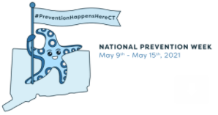 | Monday, May 10  “If They Had Known”  Online Documentary Viewing about mixing prescription drugs with alcohol  7-8pm  RSVP for Zoom at info@positivedirections.org  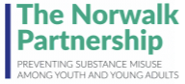 | Wednesday, May 12  CT Change the Script Van  11-1pm, 299 Greenwich Ave, Greenwich  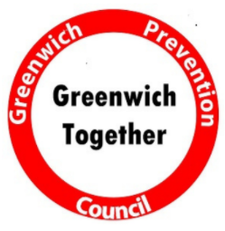 | Calm for the Community  Wellness fair and CT Change the Script Van  For parents of school children  2:30-5pm  Sherman Town Green | CT Drug Trends: Bridging The Gap Between Public Health and Public Safety  2-3:00 pm Virtual  Register at  https://www.ctclearinghouse.org/registration/  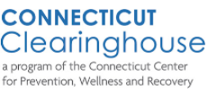
 | Adolescent Mental Health in 2021  Challenges & Caregiver Strategies w/ Dr. Aaron Weiner  6:30pm  Register Here |  | SMART Recovery Teen Group  Free in-person groups for Norwalk Teens  3:30-5:00pm  NHS/PTECH Math Resource Center | Youth Town Hall on Mental Health  7-8:00pm  Online  More info Here | Thursday, May 13  New England PTTC Vaping Graphic Panel  1:00 pm, Zoom  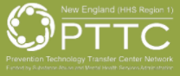 | Narcan Training  10-12:00pm Virtual  Register by emailing Cherish  Cherish.robertson@liberationprograms.org | Early Psychosis Basics  2-3:30 pm Zoom  Register at  https://www.eventbrite.com/e/early-psychosis-basics-training-tickets-151252288667 | Read Along of Gizmo’s Pawesome Guide to Mental Health  7-7:45pm Virtual  For youth ages 5-11  Register at https://ctstatewidegizmo.attendease.com/  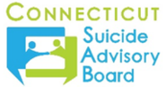
Monday, May 17  Raising Children with Resilience and Grit During the Pandemic & Beyond  10-12 pm  Register Here |  |  | Question. Persuade. Refer  QPR (suicide prevention) Training  5-6:30 pm Virtual  RSVP by emailing  info@thehubct.org | Tuesday, May 18  “Learning to Cope When Things Get Tough”  Workshop made by & for young people in CT  3:30-5:00pm  Virtual – more info Here  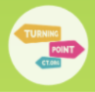 | Wednesday, May 19  Narcan Training  3-4:00pm Virtual  Register by emailing kaitlin@ryasap.org | A Better High: Laugh, Help, Run, Love & Other Ways to Get Naturally High  7-8:30 pm  Presentation with author Matt Bellace  Register Here | Shattering The Stigma of Mental Health  Emily Torchiana TEDx Speaker and Suicide Attempt Survivor  7-8:30 pm Woodway Country Club 540 Hoyt ST. Darien, CT  Or  Virtually – Register at Here | SMART Recovery Teen Group  Free in-person groups for Norwalk Teens  3:30-5:00pm  BMHS/CGS Room 1205
Thursday, May 20  Prevention, Wellness, and Healing: A Symposium With a Youth Perspective  9-2:00 pm  Register Here |  |  | Friday, May 21  2021 Women & Opioids Conference  9-4pm - Zoom  Register Here | Saturday, May 22  NAMIWalks Your Way CT: A United Day of Hope  All Day – Social media and live feeds  Register Here | Norwalk Mental Health Fair  11-2:00 pm  Location TBD | Wednesday, May 26  Question. Persuade. Refer  QPR (suicide prevention) Training  11:30-1:00 pm Virtual  RSVP by emailing  info@thehubct.org | Laughing Yoga  4-5:00 pm  Instructor Shelli Sullivan  Location TBD | SMART Recovery Teen Group  Free in-person groups for Norwalk Teens  3:30-5:00pm  NHS/PTECH Math Resource Center
Thursday, May 27  Stamford’s Mental Health and Wellness Virtual Summit  For Students/Parents/Residents  Time TBD |  |  | Firearms, Means Safety, and Suicide Prevention: A Clinical Workshop  1-4:30 pm Cost $40  Register Here  